
Physics Lab
Department of MPS

Course Name: Engineering Physics -1

Course Code : PHY 109 LAB

Section No :

Group No :

Experiment No :

Name of the Experiment:

Date of Allocation :

Date of Submission :

Submitted To :

Student’s ID :

Student’s Name:


Physics Lab
PHY-109 LAB
Experiment No: 04
Name of the Experiment:
To determine the wavelengths of various spectral lines by a spectrometer using a plane diffraction grating.
Theory:
- When light passes through a narrow slit then light spreads out, this phenomenon is called diffraction.  - When wavelength, λ is comparable with the slit’s width, d, then diffraction becomes pronounced.$d≈λ$ | Figure:$d>λ$. Diffraction (spreading) is not pronounced. | Figure: $d≈λ$ Diffraction not pronounced.
- The diffraction grating, a useful device for analyzing light sources, consists of a large number of equally spaced parallel slits.
- If a grating is ruled with 5000 lines/cm then it has a slit spacing $d=\frac{1}{5000}cm=2×{10}^{-4}cm$.
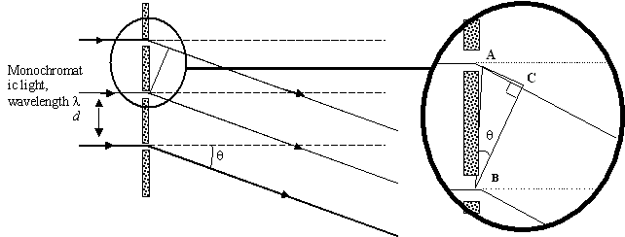
a+b
Figure: Side view of a diffraction grating. The slit separation is d, and the path difference between adjacent slits is $dsinθ$

If parallel rays of monochromatic light of wavelength λ, coming out of the collimator of a spectrometer falls normally on a plane diffraction grating placed vertically on the prism table then a series of diffracted image of the collimator slit will be seen on both sides of the direct image.

Parallel rays of a monochromatic light of wavelength λ are incident on a diffraction grating in which the slit separation is (a+b). If the grating has N lines per unit length, then the grating spacing is given by:
…………………………………(1)
Constructive interference only occurs along a few precise directions, one of which is shown in the diagram. Light from A must be in phase with light from B, and this can only happen when the path difference is a whole number of complete wavelengths (even number of half-wavelengths).
Path difference, AC = n λ where n = 0, 1, 2, 3...

Therefore, …………………………….(2)
Where, θ is the angle of diffraction.

The term n is called the spectrum order. If n = 1, we have the first order diffraction maximum.
Sin θ can never be greater than 1, so there is a limit to the number of spectra that can be obtained. Thus ………………………………… (3)
………………………………… (4)
The wavelength λ of any unknown light can be found out with the help of equation (4).

Apparatus:

Spectrometer, spirit level, plane diffraction grating, discharges tubes, etc.

Procedure:

The preliminary adjustments for this experiment are twofold
(a) Those of the spectrometer and
(b) Those of the grating.
(a) Focus the telescope of the spectrometer for paral1el rays in the usual manner

(1) To make the plane of the grating vertical and set it for normal incidence:

- Focus the telescope towards the direct light coming through the collimator. Note the position of the telescope (direct reading). Then turn the telescope through exactly 90º and fix it there.

- Place the grating, mounted in its holder, on the prism table. The grating should be so placed that the lines of the grating are perpendicular to the table and the plane of the grating, defined by the ruled surface, passes through the center of the table so that the ruled surface, extends equally on both sides of the center. At the same time, the grating should be perpendicular to the line joining any two of the leveling screws (say E and F).

- Rotate the prism table till you get, on the cross wires of the telescope, an image of the slit formed by reflection at the grating surface. The image may not be at the center of the crosswires. If so, turn one of the screws till the center of the image reaches the intersection of the cross-wires. In this position the plane of the grating has been adjusted to be vertical. The angle at which light is now incident on the grating is obviously 45°. Read the position of the prism table, using both the venires.

- Now look carefully at the grating on the table and ascertain whether the surface of the grating which first receives the light is the one which also contains the lines. (Allow the light to be reflected alternately from both the surfaces of the grating and observe the image of the slit through the telescope, whose axis must be kept perpendicular to that of the collimator. It will be found that the image formed by one surface of the grating is brighter than that formed by the other surface. The surface which produces the less sharp image is the one which contains the lines). If so, turn the prism table either through 135°or 45° in the appropriate direction so that at the end of this rotation the ruled surface will face the telescope, while light from the collimator will be incident normally on the grating. If it is the no ruled surface of the grating which first receives the light, then the prism table should be rotated through an angle of 45°or 135° in the proper direction to bring the grating into the position specified above. Fix the prism table in its new position.

(2) To make the grating vertical:
In operation (1) you have made the plane of the grating vertical but the lines may not be so. The grating would require a rotation in its own plane to bring this about.

- Rotate the telescope to receive the diffracted image on either side of the direct image. If the lines of the grating are not vertical, the diffracted image on one side of the direct image will appear displaced-upwards while that on the other side will appear displaced downwards. But actually, the spectra are formed in a plane perpendicular to the lines of the grating.  - Now set the telescope to receive the diffracted image in the highest possible order on one side and turn the third screw of the prism table till the center of the image is brought on the junction of the cross-wires. This screw rotates the grating in its own plane as a result of which the lines become vertical. On turning the telescope, it will be observed that the centers of all the diffracted images (on both sides of the direct image) lie on the junction of the cross-wires. This completes the adjustments required for mounting of the grating. | 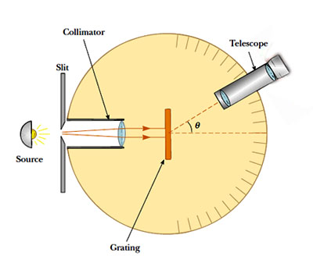

Now proceed to take readings as follows:
- With sodium discharge tube placed in front of the collimator slit, set the telescope on, say, the first order of the diffracted image on one side of the direct image. Focus the telescope and take the reading using both the venires. Then focus the telescope on the diffracted image of the same order on the other side of the direct image. Again, take the reading. The difference between these two readings are twice the angle of diffraction for this order of image. (figure - beside). (Alternately you can take the readings of the diffracted image and the direct image. The difference is the angle of diffraction. But the previous method is to be preferred since it minimizes error in observation).  - Similarly measure the angle of diffractions for the second order, third order and so on. During these measurements the width of the slit should be as narrow as possible. The readings for each diffracted image should be taken at least three times for three independent settings of the telescope. The cross-wires should always be focused on the same edge of the image of the slit.  - With the help of equation compute N from the known values of the wavelength for sodium-D lines and the angles of diffraction obtained for two or three of the highest orders of the spectra | 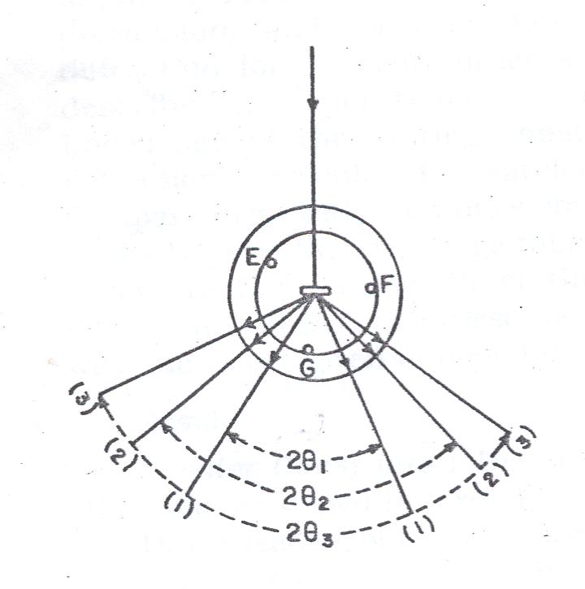

Note: In case the Na-D (yellow) lines are not resolved then the cross-wire should be focused on the middle of the image. In that case calculate N by assuming λ to be 5893 AU.
But if the lines D₁ (5890 A. U.) and D₂ (5896 A U.) are resolved readings should be taken for each of these lines and N should be computed separately from each set of readings.

- Replace the sodium discharge tube by another discharge tube say of mercury which should be mounted practically in contact with the slit. Instead of one or two lines as in the case of sodium. you will now see a large number of spectral lines of different colors. Adjust the position of the discharge tube till the spectrum look brightest. Identify the different lines of the spectrum (see discussion) and for each line determine the angle of diffraction for as many orders as possible in the manner described in operations (i) and, (ii). Then from the knowledge of the grating constant N and the order of diffraction n, calculate the wavelength of each of these lines. Compare them with the values obtained from the table.

- Replace this discharge tube with another, say of neon. Calculate the wavelength of the prominent lines of the spectrum of the manner described above and compare them with the values given in the table.

Data Sheet: Diffraction grating experiment:

1 inch = 2.54 cm. 1 nm (nanometer)= 10⁻⁷cm = 10⁻⁹m

= ………….

Grating constant, N = the number of lines or rulings per centimeter of the grating surface

=…………………….

Data Sheet: Diffraction grating experiment:

1 inch = 2.54 cm. 1 nm (nanometer)= 10⁻⁷cm = 10⁻⁹m

= ………….

Grating constant, N = the number of lines or rulings per centimeter of the grating surface

Number of order, n | Description of the line | Reading for the angle of Diffraction θ |  |  |  |  |  |  |  | Wave length,  nm
 |  | Left Side |  |  | Right Side |  |  | 2 θ = L ~ R  in degree | θ  in degree
 |  | Main scale reading (S)  in degree | Vernier scale reading (V)  V = V.C.×Div.  in degree | Total reading (L)  L = S + V  in degree | Main scale reading (S)  in degree | Vernier scale reading (V)  V = V.C.×Div.  in degree | Total reading (R)  R = S + V  in degree
1st order | Violet
 | Indigo
 | Blue
 | Green
 | Yellow
 | Orange
 | Red
2nd order | Violet
 | Indigo
 | Blue
 | Green
 | Yellow
 | Orange
 | Red
=…………………….

Calculation: Wavelength, = …………………………

 | Violet | Indigo | Blue | Green | Yellow | Orange | Red
Standard value of Wavelength of different Color of Sodium Light (mainly yellow color )Source  nm | 447 | 450 | 471 | 502 | 588 | 620 | 668
Standard value of Wavelength of different Color of Mercury Light (mainly Violet color )Source  nm | 405 | 436 | - | 546 | 578 | 615 | -
Experimental Value of  wavelength in nm | …. | …. | …. | …. | …. | …. | ….

Percentage difference (Violet color) = ……….

Percentage difference (Indigo color) = ……….

Percentage difference (Blue color) = ……….

Percentage difference (Green color) = ……….

Percentage difference (Yellow color) = ……….

Percentage difference (Orange color) = ……….

Percentage difference (Red color) = ……….

Results:

 | Violet | Indigo | Blue | Green | Yellow | Orange | Red
Wavelength in nm | …. | …. | …. | …. | …. | …. | ….

Discussions:

- The source must be in front of the collimator slit so that image appears bright.

- The vertical cross-wire or better the centre of the cross-wires should be made coincident with the same edge of the slit image. Care should be taken so that there is no parallax between the cross-wires and the slit image.

- For the final setting, the telescope must be rotated carefully with the tangent screw always in the same direction so as to avoid back-lash error.

- The width of the slit image should be as narrow as possible.

- In taking reading care should be taken to ascertain whether the zero of the main circular scale has been crossed in going from one position to other.

Pre - Lab Exercise:

- What is diffraction?

...................................................................................................................................................

...................................................................................................................................................

- What is diffraction grating? If the slit spacing of a diffraction grating is $d=\frac{1}{5000}cm=2×{10}^{-4}cm$ d = 2×10 ^{̶ 4}cm, what is its grating constant?

...................................................................................................................................................

...................................................................................................................................................

...................................................................................................................................................

...................................................................................................................................................

- In diffraction grating experiment, the deviation angle for first order violet color is 13⁰. The grating constant is 15,000 lines per inch. Find the wavelength of violet color light in A.U.?

...................................................................................................................................................

...................................................................................................................................................

...................................................................................................................................................

- What happens when grating constant, N, is increased and wavelength, λ, remains constant? Spreading (deviation) of color increases or decreases? And why?

...................................................................................................................................................

...................................................................................................................................................

- Which color of light has greatest wavelength? In the diffraction grating spectrum, which color bends the most? And why?

...................................................................................................................................................

...................................................................................................................................................

Sample oral Questions and Answers
Name of the experiment:
To determine the wavelengths of various spectral lines by a spectrometer using a plane diffraction grating.

- What is diffraction grating?  Ans: When light passes sharp edges or goes through narrow slits the rays are deflected and produce fringes of light and dark bands). This is called diffraction.  In optics, a diffraction grating is an optical component with a regular pattern, which splits and diffracts light into several beams travelling in different directions. The directions of these beams depend on the spacing of the grating and the wavelength of the light so that the grating acts as the dispersive element.  - What is grating element and grating constant?  Ans: A large number of closely spaced parallel slits separated by equal opaque spacings form a diffraction grating.  (a+ b) is called is called grating element, where “a” is the width of opaque space and “b” is the width of slit. is called grating constant. N is the number of slits per unit length. | - 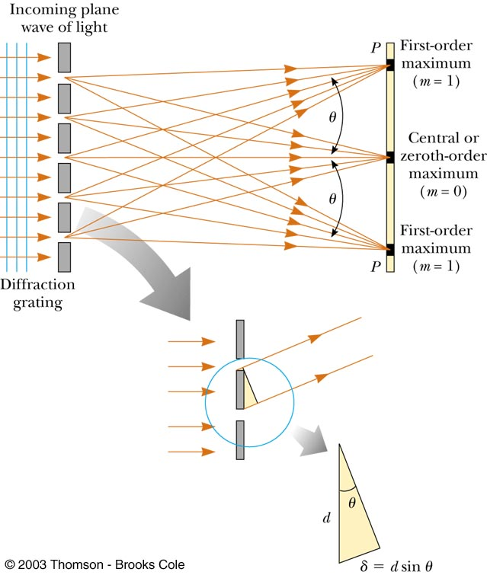  For first maximum,  Path difference = d Sinθ  Again,  Where, N = number of slits per unit length.
- Diffraction grating equation is, . (For first maximum, n =1)
    - What happens when N is increased and λ remains constant? Spreading of color increases or decreases? Why?
Ans: According to Diffraction grating equation as N increases θ increases. Therefore the spreading of colors increases.
- What happens when λ is increased and N remains constant? Spreading of color increases or decreases? Why?
Ans: According to Diffraction grating equation as λ increases θ increases. Therefore the spreading of colors increases.

